

This report describes enteric disease surveillance and investigations carried out during the second quarter of 2021 (2Q21) by OzFoodNet WA in conjunction with other Western Australian Department of Health agencies and local governments.

The increase in notifications for Shiga-toxin producing *Escherichia coli* (STEC) and yersiniosis is partly attributed to the introduction of polymerase chain reaction (PCR) testing of faecal specimens, which has greater sensitivity than culture techniques. The decrease in other enteric notifications in 2Q21 continues to be likely due COVID-19 public health measures including travel restrictions and possible improvements in hand hygiene in the general community.

**OzFoodNet Enteric Disease Surveillance Report 2ND Quarter 2021**

**Enhancing foodborne disease surveillance across Australia**

1Q21

**Most common enteric disease notifications in Quarter 2 2021**



**Change in enteric disease notifications (%)\***



**Appendix 1** Enteric diseases by public health region:

<https://ww2.health.wa.gov.au/-/media/Corp/Documents/Health-for/Infectious-disease/OZfoodnet/Word/WA-OzFoodnet-appendix1-2021-q2.docx>

*Percentage change in the number of notifications in the current quarter compared to the historical 5-year mean for the same quarter. Positive values indicate an increase when compared to the historical 5-year mean of the same quarter. Negative values indicate a decrease when compared to the historical 5-year mean of the same quarter. Percentage change should be interpreted with caution when the number of cases is small.

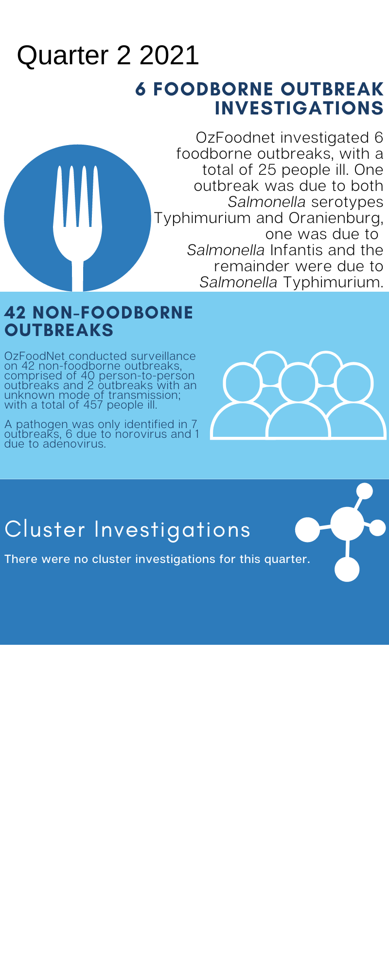****

**Outbreaks in Quarter 1 2021**

**Appendix 2** Details of foodborne outbreaks investigated in Quarter 2, 2021:

<https://ww2.health.wa.gov.au/-/media/Corp/Documents/Health-for/Infectious-disease/OZfoodnet/Word/WA-OzFoodnet-appendix2-2021-q2.docx>

**Key trends from Quarter 2 2021**

***Salmonella* Typhimurium (STM)** **MLVA 03-17-09-12-523**

There has been a 57% decrease in all salmonellosisnotifications in the second quarter of 2021 with 225 notifications compared to the 5-year average (2016-2020) of 528.4 notifications. The most common serovar of *Salmonella* for 2Q21 was STM. There were 113 STM notifications in 2Q21, a 62% decrease compared to the 5-year average of 296.8 notifications. The MLVA type 03-17-09-12-523 was the most common in 2Q21 as has been the case since its emergence in September 2016.

From September 2016 to June 2021 there were 1967 cases notified, including 33 cases in 2Q21. This MLVA type was the single most common MLVA type notified in 2Q21, constituting 29% of STM notifications for the quarter. There were two point-source outbreaks of MLVA 03-17-09-12-523 identified in this quarter comprising of 7 cases, however, these were notified to OzFoodNet in the first quarter and have been accounted for in the 1Q21 report. Of the 33 cases notified in 2Q21, none were identified as being a part of an outbreak. The majority of these (88%) resided in the Perth metropolitan area. Hospitalisation status was ascertained for 29 community cases; 14% were hospitalised.



Figure: Notifications of *Salmonella* Typhimurium MLVA 03-17-09-12-523 in WA, September 2016 to June 2021

**Yersiniosis**

There were eight notifications reported in 2Q21, all were culture positive. Six were metropolitan residents and one each from the Wheatbelt and Great Southern regions. There were no point-source outbreaks identified in this reporting period.

**STEC**

Twelve of the 33 notifications were culture positive and serotyping was performed for 10 cases. The most common being serotype O157:H7 (n=3), and the remainder comprised of single cases of serotypes O91:H14, O112:H19, O174:H2, O8:H28, OGp8:H7, O5:H19 and O74:H20. No point-source outbreaks were identified in 2Q21. Some of the increase is likely due to PCR testing of all faecal specimens by one private laboratory since the fourth quarter of 2018.

***Listeria***

There were two notifications of *Listeria monocytogenes* in 2Q21, both non-perinatal cases, including an 83-year old male in which the diagnosis was made via post-mortem. The other case was a 79-year old male who was diagnosed with septicaemia. Co-morbidities included inflammatory muscle disease and heart disease. Food eaten during incubation period included a number of high-risk foods. *Listeria* strains of cases were typed and considered unique.