Foodborne disease surveillance and outbreak investigations in Western Australia, second quarter 2017

**Enhancing foodborne disease surveillance across Australia**



**Communicable Disease Control Directorate**



OzFoodNet, Communicable Disease Control Directorate

**Acknowledgments**

Acknowledgement is given to the following people for their assistance with the activities described in this report: Mr Damien Bradford, Ms Cara Minney-Smith, Ms Lyn O’Reilly, Ms Marilina Chiari and the staff from the enteric, PCR and food laboratories at PathWest Laboratory Medicine WA; Mr John Coles and other staff from the Food Unit of the Department of Health, Western Australia; Public Health Nurses from the metropolitan and regional Population Health Units; and Local Government Environmental Health Officers.

**Contributors/Editors**

Barry Combs, Nevada Pingault and Niki Foster

Communicable Disease Control Directorate

Department of Health, Western Australia

PO Box 8172

Perth Business Centre

Western Australia 6849

Email: [OzfoodnetWA@health.wa.gov.au](mailto:OzfoodnetWA@health.wa.gov.au)

Telephone: (08) 9388 4999

Facsimile: (08) 9388 4877

Web:

OzFoodNet WA Health [www.public.health.wa.gov.au/3/605/2/ozfoodnet_enteric_infections_reports.pm](http://www.public.health.wa.gov.au/3/605/2/ozfoodnet_enteric_infections_reports.pm)

OzFoodNet Department of Health

[www.ozfoodnet.gov.au/](http://www.ozfoodnet.gov.au/)

**Disclaimer**:

Every endeavour has been made to ensure that the information provided in this document was accurate at the time of writing. However, infectious disease notification data are continuously updated and subject to change.

This publication has been produced by the **Department of Health, Western Australia**.

# Executive summary

During the second quarter of 2017 (2Q17), the Western Australian (WA) OzFoodNet team conducted surveillance of enteric diseases, undertook investigations into outbreaks and was involved with ongoing enteric disease research projects. The most common notifiable enteric infections in WA were campylobacteriosis (n=705), salmonellosis (n=622), rotavirus infection (n=236) and cryptosporidiosis (n=89) (Figure 1). Compared to the applicable 5-year second quarter means (2QM), there were increases in notifications of campylobacteriosis (23%), salmonellosis (74%), rotavirus infections (134%) and cryptosporidiosis (21%). The large increase in salmonellosis was primarily driven by an increase in *S.* Typhimurium MLVA type 03-17-09-12-523 notifications. There were six foodborne outbreaks investigated in the second quarter, all due to *Salmonella* Typhimurium and four of which were associated with consumption of egg dishes. The number of foodborne outbreaks in the 2Q17 was nearly two times the second quarter 5-year mean (n=3.4). OzFoodNet also conducted surveillance of 34 non-foodborne outbreaks. Of these, the most common mode of transmission was person-to-person (25 outbreaks), with a total of 431 people ill. Norovirus was the most commonly reported pathogen, being identified in 13 outbreaks.

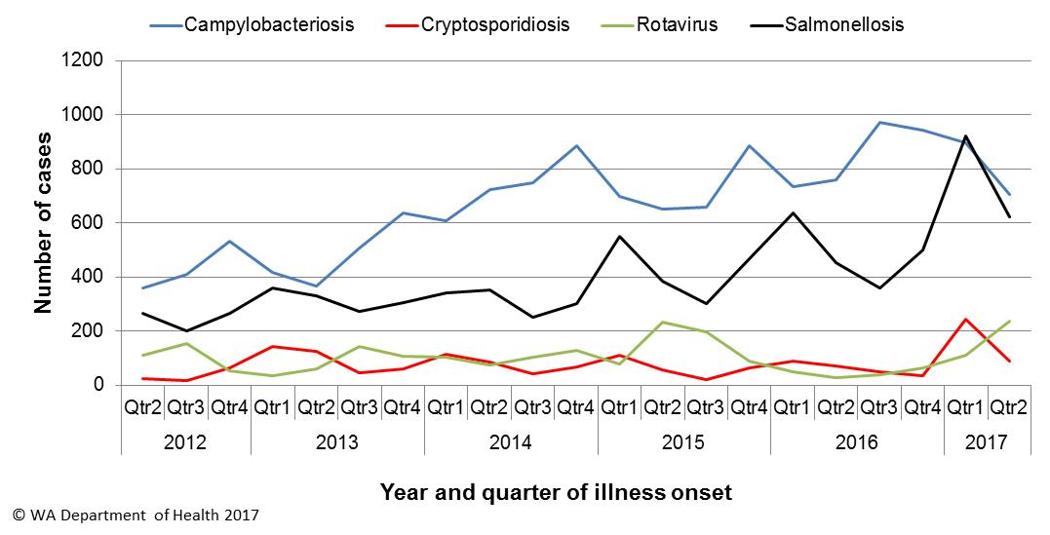

Figure 1: Notifications of the four most common enteric diseases by quarter from 2012 to 2017, WA

**Table of Contents**

Executive summary 2

1 Introduction 5

2 Incidence of notifiable enteric infections 6

2.1. Methods 6

2.2. Campylobacteriosis 6

2.3. Salmonellosis 7

2.4. Rotavirus infection 9

2.5. Cryptosporidiosis 9

2.6. Other enteric diseases and foodborne illness 10

3 Foodborne and probable foodborne disease outbreaks 12

3.1. Cafe Outbreak, *Salmonella* Typhimurium (outbreak code 042-2017-013) 12

3.2. Café Outbreak, *Salmonella* Typhimurium (outbreak code 042-2017-017) 13

3.3. Private function, *Salmonella* Typhimurium (outbreak code 042-2017-018) 13

3.4. Childcare centre, *Salmonella* Typhimurium (outbreak code 042-2017-019) 13

3.5. Private function, *Salmonella* Typhimurium (outbreak code 042-2017-020) 14

3.6. Restaurant outbreak, *Salmonella* Typhimurium (outbreak code 042-2017-021) 14

4 Cluster investigations 15

4.1. *Salmonella* Typhimurium PFGE 0001, PT 9 15

4.2. *Salmonella* Typhimurium MLVA 03-17-09-12-523 16

4.3. Rotavirus in the Kimberley region 18

4.4. *Salmonella* Typhimurium MLVA 03-26-16-12-523 19

4.5. *Salmonella Singapore* 19

5 Non-foodborne disease outbreaks and outbreaks with an unknown mode of transmission 20

5.1. Person-to-person outbreaks 20

5.2 Outbreaks with unknown mode of transmission 21

6 Site activities 22

7 References 23

**List of Tables**

Table 1: Number of campylobacteriosis notifications, 2nd quarter 2017, WA, by region 7

Table 2: Number of salmonellosis notifications, 2nd quarter 2017, WA, by region 8

Table 3: Number of rotavirus notifications, 2nd quarter 2017, WA, by region 9

Table 4: Number of cryptosporidiosis notifications 2nd quarter 2017, WA, by region 10

Table 5: Summary of number of notified cases of enteric notifiable diseases in WA in the second quarter 2017 compared to historical means 12

Table 6: Outbreaks with non-foodborne transmission, 2nd Quarter 2017, WA 20

**List of Figures**

Figure 1: Notifications of the four most common enteric diseases by quarter from 2012 to 2017, WA 2

Figure 2: Notifications of Salmonella Typhimurium PFGE 0001 in WA, 2013 to June 2017 16

Figure 3: Notifications of Salmonella Typhimurium MLVA 03-17-09-12-523 in WA, 2016 to March 2017 18

Figure 4: Rotavirus notifications in the Kimberley, Pilbara and Goldfields public health unit regions 19

**Notes:**

1. All data in this report are provisional and subject to future revision.
2. To help place the data in this report in perspective, comparisons with other reporting periods are provided. As no formal statistical testing has been conducted, some caution should be taken with interpretation.

Copyright to this material is vested in the State of Western Australia unless otherwise indicated. Apart from any fair dealing for the purposes of private study, research, criticism or review, as permitted under the provisions of the Copyright Act 1968, no part may be reproduced or re-used for any purposes whatsoever without written permission of the State of Western Australia.

# Introduction

It has been estimated that there are 5.4 million cases of foodborne illness in Australia each year at a cost of $1.2 billion per year1. This is likely to be an underestimate of the total burden of gastrointestinal illness as not all enteric infections are caused by foodborne transmission. Other important modes of transmission include person-to-person, animal-to-person and waterborne transmission. Importantly, most of these infections are potentially preventable through interventions at the level of primary production, commercial food handling, households or institution infection control, as appropriate.

This report describes enteric disease surveillance and investigations carried out during the second quarter of 2017 by OzFoodNet WA, other WA Department of Health (WA Health) agencies and local governments. Most of the data are derived from reports by doctors and laboratories to WA Health of 16 notifiable enteric diseases. In addition, outbreaks caused by non-notifiable enteric infections are also documented in this report, including norovirus, which causes a large burden of illness in residential (mostly aged) care facilities (RCF) and the general community.

OzFoodNet WA is part of the Communicable Disease Control Directorate (CDCD) within WA Health, and is also part of the National OzFoodNet network funded by the Commonwealth Department of Health2. The mission of OzFoodNet is to enhance surveillance of foodborne illness, including investigating and determining the cause of outbreaks. OzFoodNet also conducts applied research into associated risk factors and develops policies and guidelines related to enteric disease surveillance, investigation and control. The OzFoodNet site based in Perth is responsible for enteric disease surveillance and investigation in WA.

OzFoodNet WA regularly liaises with staff from: Public Health Units (PHUs); the Food Unit in the Environmental Health Directorate of WA Health; and the Food Hygiene, Diagnostic and Molecular Epidemiology laboratories at PathWest Laboratory Medicine WA.

PHUs are responsible for a range of public health activities, including communicable disease control, within their respective administrative regions. The PHUs monitor RCF gastroenteritis outbreaks and provide infection control advice. The PHUs also conduct follow-up of sporadic cases of important enteric diseases including typhoid, paratyphoid and hepatitis A.

The Food Unit liaises with Local Government (LG) Environmental Health Officers (EHO) during the investigation of food businesses. The Food Hygiene, Diagnostic and Molecular Epidemiology laboratories at PathWest Laboratory Medicine WA provide public health laboratory services for the surveillance and investigation of enteric disease.

# Incidence of notifiable enteric infections

## Methods

Enteric disease notifications were extracted from the Western Australian Notifiable Infectious Diseases Database (WANIDD) by optimal date of onset (ODOO) for the time period 1st April 2012 to 30th June 2017. The ODOO is a composite of the ‘true’ date of onset provided by the notifying doctor or obtained during case follow-up, the date of specimen collection for laboratory notified cases, and when neither of these dates is available, the date of notification by the doctor or laboratory, or the date of receipt of notification, whichever is earliest. Rates were calculated using estimated resident population data for WA from Rates Calculator version 9.5.5 (WA Health, Government of Western Australia), which is based on 2011 census data. Rates calculated for this report were annualised (rates for the quarter multiplied by four) and have not been adjusted for age.

## Campylobacteriosis

Campylobacteriosis was the most commonly notified enteric disease in WA during the second quarter of 2017 (2Q17), with 705 notifications and a rate of 104 cases per 100 000 population per year (Table 1). There was a 23% increase in campylobacteriosisnotifications in the 2Q17 compared with the 5-year second quarter mean (2QM) of 571 notifications. The increase appeared to be due to sporadic disease, as there were no identified *Campylobacter* outbreaks during the 2Q17. At least some of the increase is likely to be due to the introduction by one large private pathology laboratory of polymerase chain reaction (PCR) testing of faecal specimens, which has greater sensitivity than culture techniques.

The place of acquisition of infection was reported for 56% (n=391) of cases, of which 75% (n=294) were locally acquired and 24% (n=92) were acquired overseas.

Table 1: Number of campylobacteriosis notifications, 2nd quarter 2017, WA, by region



**\***Percentage change in the number of notifications in the current quarter compared to the historical 5-year mean for the same quarter. Positive values indicate an increase when compared to the historical 5-year mean of the same quarter. Negative values indicate a decrease when compared to the historical 5-year mean of the same quarter. Percentage change should be interpreted with caution when the number of cases is small.

NA: not applicable as there is a 0 value in the calculation for the 2nd quarter % change

## Salmonellosis

Salmonellosis was the second most commonly notified enteric disease in WA in the 2Q17, with 622 notifications and a rate of 92 cases per 100 000 population per year (Table 2). The number of salmonellosisnotifications in the 2Q17 was 74% higher than the 2QM (n=357), with substantial increases seen in most PHUs. There was a large *Salmonella* increase in the Goldfields region which was due to an outbreak in a child care centre (see section 3.4).

Place of acquisition of infection was reported for 78% (n=485) of cases, of which 82% (n=399) were locally acquired, 17% (n=80) were acquired overseas and 1% (n=6) were acquired interstate.

The most commonly reported *Salmonella* serotype was *S*. Typhimurium (STM) (n=346, 56%), and of those cases with information on place of acquisition (n=285, 82%), 97% of cases (n=277) were locally acquired. Pulsed-field gel electrophoresis (PFGE) was previously used for subtyping of STM in WA, but as of the beginning of 2016, multi locus variable number tandem repeat analysis (MLVA) has replaced PFGE. The most common MLVA types for 2Q17 were 03-17-09-12-523 (n=131, 38%, PFGE type 0043), 03-17-10-12-523 (n=26, 8%, PFGE type 0043), 03-25-16-11-523 (n=18, 5%, PFGE type 0001) 03-25-18-11-523 (n=16, 5%, PFGE type 0001), and 03-13-11-10-523 (n=13, 4%, PFGE type 0039). The MLVA type 03-17-09-12-523 emerged in the 4Q16 and has been associated with a number of point source outbreaks (Sections 3 and 4). There has also been an ongoing community wide outbreak of PFGE 0001 and associated MLVA types in WA over the past two years (Section 4).

Table 2: Number of salmonellosis notifications, 2nd quarter 2017, WA, by region



**\***Percentage change in the number of notifications in the current quarter compared to the historical 5-year mean for the same quarter. Positive values indicate an increase when compared to the historical 5-year mean of the same quarter. Negative values indicate a decrease when compared to the historical 5-year mean of the same quarter. Percentage change should be interpreted with caution when the number of cases is small.

*S*. Enteritidis was the second most common *Salmonella* serotype (n=39, 6%), with most (n=36, 92%) cases acquired overseas, primarily after travel to Indonesia (n=29, 81%), and almost exclusively to Bali.

*Salmonella* Paratyphi B bv Javawas the third most common serotype (n=26), and of those cases with known place of acquisition, 7% of cases were acquired in WA and 93% acquired overseas. There were also 24 notifications of *Salmonella* Singapore and most (92%) of these notifications were acquired in WA (see cluster investigations Section 4).

There were 15 notifications of *Salmonella* that had no serotype. Most (60%) of these notifications were from one laboratory that first uses PCR screening for enteric pathogens. Specimens that are subsequently culture negative remain as a “PCR only” notification.

## Rotavirus infection

In the 2Q17 there were 236 notifications of rotavirus infection (35 cases per 100 000 population per year), a 134% increase compared with the 2QM (Table 3). (see Table 4). There were increases in notifications in most public health regions with the greatest proportional increases occurring in the Kimberley, Pilbara and Goldfields regions, associated with epidemic activity, primarily in Aboriginal children. On a statewide basis, of the cases with known Aboriginality status, 66% were non-Aboriginal and 34% were Aboriginal people. The median age was 2 years (range <1 years to 87 years).

Table 3: Number of rotavirus notifications, 2nd quarter 2017, WA, by region



*Percentage change in the number of notifications in the current quarter compared to the historical 5-year mean for the same quarter. Positive values indicate an increase when compared to the historical 5-year mean of the same quarter. Negative values indicate a decrease when compared to the historical 5-year mean of the same quarter. Percentage change should be interpreted with caution when the number of cases is small.

NA: not applicable as there is a 0 value in the calculation for the 1st quarter % change

## Cryptosporidiosis

In the 2Q17 there were 89 cryptosporidiosis notifications (13 cases per 100 000 population per year), a 21% increase compared to the 2QM (Table 4).

The place of acquisition of infection was reported for 66% (n=59) of cases of which 81% (n=48) were locally acquired.

Table 4: Number of cryptosporidiosis notifications, 2nd quarter 2017, WA, by region



**\***Percentage change in the number of notifications in the current quarter compared to the historical 5-year mean for the same quarter. Positive values indicate an increase when compared to the historical 5-year mean of the same quarter. Negative values indicate a decrease when compared to the historical 5-year mean of the same quarter. Percentage change should be interpreted with caution when the number of cases is small.

NA: not applicable as there is a 0 value in the calculation for the 2nd quarter % change

## Other enteric diseases and foodborne illness

During the 2Q17, other enteric disease notifications included:

* **Shigellosis**: There were 36 culture positive shigellosis notifications in 2Q17, 154% higher than the 2QM (n=14.2) (Table 5). *Shigella* *sonnei* was the most commonly notified species (21/36; 58%), with 15 cases of *S. sonnei* biotype A and 6 cases of *S. sonnei* biotype B. There were also 13 cases of *S. flexneri* and two cases of *S. boydii*. Of the notified cases, 21 (58%) were Aboriginal people and 15 (42%) were non-Aboriginal people. The public health region with the most cases was the Pilbara with 9 cases (25%). The place of acquisition of infection was reported for 67% (n=24), and of these cases, 75% (n=18) were acquired in WA.
* **Hepatitis A infection:** Two hepatitis A cases were notified in 2Q17, both acquired overseas, in the Philippines and Hungary, respectively.
* **Yersiniosis:** There were seven cases of culture-positive yersiniosis notified in 2Q17 and most (86%) cases acquired their illness in Western Australia.
* **Shiga toxin producing *E. coli* (STEC):** Seven cases were notified in 2Q17 compared to the 2QM of 1.4 cases. Prior to 2016, STEC was only diagnosed at PathWest’s Nedlands laboratory, by culture. The increase in cases in 2Q17 was likely due to the introduction in 2016 by one laboratory of PCR testing for STEC on stool samples with bloody diarrhoea (macroscopic or history) and PCR testing of any stool sample by Dr’s request from another laboratory. The seven cases included four females and three males, ranging in age from <1-76 years (median 58 years). Four cases had an acute illness with a specific onset date and bloody diarrhoea. Three cases had no acute illness, with one case having ongoing diarrhoea for more than 5 months, one case had bloating and one case had a single episode of bloody mucus stool. One case with acute illness was overseas acquired following travel to Bali, while the remaining three cases were locally acquired with no recognised exposures in common with other cases.
* **Haemolytic uraemic syndrome (HUS)**: There was one notification: a 14 year old female with bloody diarrhoea but who was PCR negative and culture negative for STEC, and had no identified cause of HUS.
* **Typhoid fever:** Five cases and all had travelled to India.
* **Paratyphoid fever:** One case who had travelled to India.
* ***Vibrio parahaemolyticus*:** There were three *V. parahaemolyticus* notifications in 2Q17. Two cases acquired their infection in Western Australia: both were wound infections from cuts sustained in a water environment. The third case acquired their infection overseas in Thailand.
* **Hepatitis E:** Two cases, one who had travelled to Indonesia and one who had travelled to Bangladesh.
* **Listeriosis:** Two cases.
  + One case in a 32 year old pregnant female. The foetus died as a result of the infection. The case had lived overseas during her exposure period.
  + One case in a 32 year old female who was not pregnant and not immunocompromised. Case had fever, myalgia, headaches and diarrhoea. She had eaten a number of high risk foods during the incubation period in Perth, but was also overseas for two days prior to illness onset.

There were no notifications forbotulism or cholera in the second quarter.

Table 5: Summary of number of notified cases of enteric notifiable diseases in WA in the second quarter 2017 compared to historical means



NA: not applicable as there is a 0 value in the calculation for the 2nd quarter % change

# Foodborne and probable foodborne disease outbreaks

There were six foodborne or probable foodborne outbreaks identified and investigated in this quarter. The number of foodborne outbreaks in the 2Q17 was nearly two fold higher than the second quarter 5-year mean (n=3.4).

## Café Outbreak, *Salmonella* Typhimurium (outbreak code 042-2017-013)

Seven people were diagnosed with *Salmonella* Typhimurium MLVA 03-17-09-12-523 after independently dining at the same restaurant between 25/3/17 and 27/3/17. Of the ill people, five (71%) were female and two (29%) was male, and the median age was 50 years. All cases had diarrhoea, one had bloody diarrhoea, and the median duration of diarrhoea was seven days. Two cases were hospitalised. The median incubation period was two days. Dishes consumed included steak sandwiches (n=2), seafood platters (n=2), chicken parmigiana (n=1), sweet potato chips (n=1), and fish and chips (n=1). All dishes contained mayonnaise/aioli sauces. The environmental investigation revealed that raw eggs from a specific WA egg producer were used to prepare the mayonnaise base for sauces and the coleslaw. Swabs of the stick blender and mayonnaise and aioli preparation and storage buckets, two eggs and samples of freshly made mayonnaise and aioli were negative for *Salmonella*. The local government requested the food business stop making raw egg food products due to the lack of a pathogen reduction step. Mode of transmission was probable foodborne.

## Café Outbreak, *Salmonella* Typhimurium (outbreak code 042-2017-017)

At least four people (3 males and 1 female, median age 33 years) from four groups became ill with *Salmonella* Typhimurium MLVA 03-13-11-10-523 after independently eating at a restaurant between 15/4/2017-05/05/2017. All cases had diarrhoea, one had bloody diarrhoea and median duration of diarrhoea was 15 days. The median incubation period was five days. At the restaurant, one case had poached eggs, two had roast lamb meals and one had a roast beef meal. It was unclear if there was a common ingredient served to each case. Mode of transmission was probable foodborne.

## Private function, *Salmonella* Typhimurium (outbreak code 042-2017-018)

Seven out of 11 people (2 males and 5 females, median age 16 years) were ill with diarrhoea and/or vomiting, including two people diagnosed with STM MLVA 03-12-11-10-523, after eating a chocolate mousse cake served at a private residence. One of the ill people had not attended the dinner but had a piece of cake brought home by an attendee. All cases had diarrhoea, one had bloody diarrhoea, and the median duration of diarrhoea was five days. No cases were hospitalised. The median incubation period was 1.3 days. Takeaway pizza was also served at the dinner but was not eaten by the ill person who had not attended the dinner, and one of the diagnosed cases. The chocolate mousse cake was homemade with raw free-range eggs from a specific WA egg producer. A formal environmental investigation was not conducted because the outbreak setting was a private residence. However, the remaining eggs from the carton and the cling wrap used to cover the cake were collected for testing. Both samples were positive for the outbreak strain of *Salmonella*. The person who prepared the cake had used their hands to separate the eggs. Mode of transmission was foodborne.

## Childcare centre, *Salmonella* Typhimurium (outbreak code 042-2017-019)

There was an outbreak at a childcare centre with 29 ill (32% male and 68% female, median age 3 years), of whom 20 were diagnosed with *Salmonella* Typhimurium MLVA 3-25-16-11-523. The 24 children and five staff who were affected had illness onsets between 20/5/2017 to the 31/5/2017, with most (72%) becoming ill between 20-22/5/2017. Ill children did not attend the childcare centre every day and Friday 19/5/2017 was the attendance day in common, closest to the onset of illness. Taking the exposure date as the 19/5/2017, the median incubation period was three days. All cases had diarrhoea and 12 (41%) had bloody diarrhoea. The implicated food eaten on the 19/5/2017 was a casserole made from frozen hash browns, vegetable puree, tinned spaghetti, topped with 30 whipped eggs, which was baked in the oven. Staff reported that the top of the casserole was still sloppy when served, and not the usual golden brown. Three brands of eggs were at the facility and may have been used in the casserole topping. None of the egg samples were positive for *Salmonella,* but a swab from a chopping board was positive for the outbreak strain. Several breaches of the Food Standards Code were noted including skills and knowledge of food handlers, cleanliness of premises and equipment and sanitising of specific equipment. Mode of transmission was foodborne.

## Private function, *Salmonella* Typhimurium (outbreak code 042-2017-020)

Four of six members of a household and a child who had visited the household became ill with diarrhoea and/or vomiting and were diagnosed with STM 3-17-09-12-523. Raw pasta that had been prepared at 4:30 pm that day and left to dry on the bench for 2 hours had been eaten during this time by all four sick members of the household. The visitor could not recall whether they ate any food while at the house but they did not stay for a meal. The two well people (parents) did not eat the raw pasta. The median age of the ill children was 10 years (range 7-11). Median incubation period was 22 hours. Symptoms included diarrhoea (5/5) and fever (5/5) with median duration of diarrhoea for 7 days and four (80%) children were hospitalised. The eggs used to make the pasta were from a specific WA egg producer. None were available for testing. The mode of transmission was probable foodborne.

## Restaurant outbreak, *Salmonella* Typhimurium (outbreak code 042-2017-021)

At least 13 people (62% male and 38% female, median age 38 years) from nine independent groups became ill with gastroenteritis symptoms after eating from a restaurant between 8/6/2017 and11/6/2017. Eight of the ill people were diagnosed with *Salmonella* Typhimurium MLVA 03-17-09-12-523. All cases had diarrhoea, two (15%) had bloody diarrhoea, and the median duration of diarrhoea was six days. The median incubation period was 21 hours. The foods were either eaten at the restaurant (n=2), purchased as takeaway (n=10) with one of these being delivered to the case, or unknown (n=1). Banh mi thit (Vietnamese pork roll) was eaten by 11 of the cases and banh mi ga nuong (Vietnamese chicken roll) was eaten by the remaining two cases. The environmental health investigation found that raw egg was used for the mayonnaise in both rolls. Microbiological sampling and a full assessment of mayonnaise preparation could not be completed as these items had been removed from the menu by the time the outbreak was identified and the environmental investigation was commenced. The brand of eggs used at the time of the outbreak could not be confirmed. Samples collected approximately one month after the outbreak occurred, after the food business began preparing these items again, were negative for *Salmonella*. Mode of transmission was probable foodborne.

# Cluster investigations

There were two ongoing and three new cluster investigations during the second quarter of 2017.

## *Salmonella* Typhimurium PFGE 0001, PT 9

Since the beginning of 2014, there has been an ongoing investigation of a community-wide outbreak in WA of notifications of MLVA types analogous to STM PFGE 0001 (Figure 2). PFGE 0001 includes multiple MLVA types. This has been the largest *Salmonella* outbreak ever investigated in WA. From January 2014 to June 2017 there were 1019 cases notified, which includes 76 cases with onset dates in the 2nd quarter of 2017. Of the 76 cases, 20 were part of a single point source foodborne outbreak (see section 3, outbreaks: 042-2017-019) and four cases were part of a separate cluster at a resort town. The remaining seemingly sporadic 52 cases, comprising 29% males and 71% females, ranged in age from <1 to 90 years (average 37 years), and most (71%) resided in the Perth metropolitan area.

Between January 2015 and June 2017 egg dishes have been the implicated source food in 17 of 18 point source outbreaks due to STM PFGE 0001. The implicated egg dishes of the 17 outbreaks included raw egg desserts (n=8) and whole egg dishes such as fried/poached eggs (n=6). In 13 of these outbreaks, a specific egg producer was identified that supplied the eggs for the implicated dishes. One WA producer was associated with seven outbreaks, and one outbreak each was associated with four other specific WA egg producers. Also one outbreak each was associated with two non-WA eggs producers. Eggs from all these producers are available in WA retail outlets.

Independent of the human outbreak investigations, non-human samples have been collected and tested either systematically or opportunistically over the corresponding period from eggs, egg laying chickens and retail chicken meat. MLVA types analogous to STM PFGE 0001 has been isolated on five occasions from eggs or egg laying chickens from three WA egg producers. These MLVA types have also been isolated from many human cases and some types (03-10-15-11-496, 03-24-16-12-525, 03-25-16-11-523) have been the cause of multiple point source outbreaks. Retail chicken meat sampled in September 2014 was also positive for PFGE 0001.

From February 2015 to March 2016, non-point source outbreak cases (“community cases”) were investigated as part of a case-control study of STM PFGE 0001 illness. Final analysis of the case control data showed that eating raw eggs was statistically associated with risk of illness.

This combined evidence suggests that eating raw/runny eggs is the cause of most identified STM PFGE 0001 point source outbreaks in WA and that contaminated eggs are likely to be the source of many of the sporadic community cases.

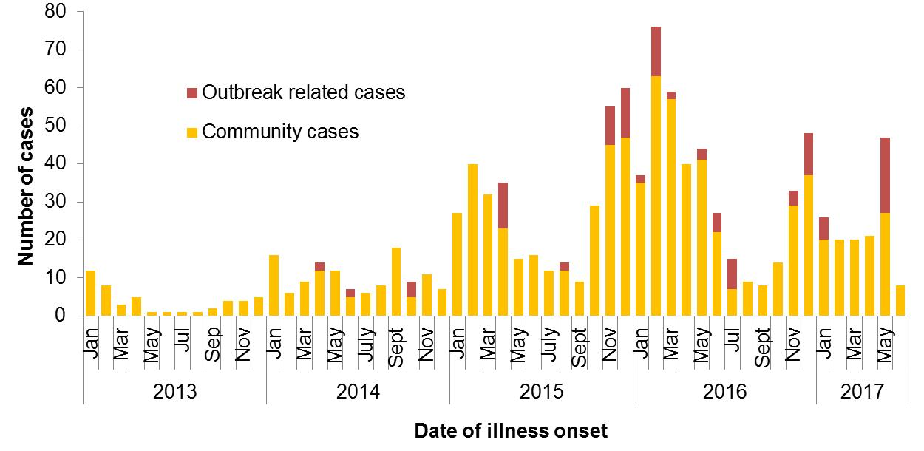

Figure 2: Notifications of *Salmonella* Typhimurium PFGE 0001 in WA, 2013 to June 2017

## *Salmonella* Typhimurium MLVA 03-17-09-12-523

*Salmonella* Typhimurium MLVA 03-17-09-12-523 has been under investigation since this type emerged with a single case in September 2016 (see 4Q16 report). From September 2016 to June 2017 there were 507 cases notified, including 131 cases in 2Q17 (Figure 3). This MLVA type was the single most common MLVA type notified in 2Q17, constituting 38% of STM notifications for the quarter. Of the 131 cases, 14 (11%) were part of three small identified point source outbreaks. These outbreaks are detailed in Section 3. The remaining 117 cases, comprising 50% males and 50% females, ranged in age from <1 to 88 years (median 29 years), and most (81%) resided in the Perth metropolitan area. Hospitalisation data was confirmed for 94 community cases, of whom 33% were hospitalised, indicative of the severity of infection.

Eggs were implicated in each of the three point source outbreaks of STM 03-17-09-12-523 in the 2Q17. The specific WA egg producer linked to two of these outbreaks was the same egg producer linked to an outbreak of this MLVA type reported in the 2017 first quarter report. A second WA egg producer was implicated in the remaining outbreak in 2Q17. This producer had not previously been associated with outbreaks of this MLVA type.

Of the 117 cases who were not part of these point source outbreaks, 94 were interviewed regarding food and other exposures; 67% had consumed eggs in their incubation period, 21% had not, and 12% were unsure. Of the 56 interviewed cases who ate eggs at home, 57% could not recall the egg brand that they ate during their incubation period. Several different egg brands were reported by the remaining cases including the brands implicated in the point source outbreaks. Egg brands of the WA egg producer linked to two outbreaks in 2Q17 was one of the two most common brands recalled amongst cases (21% of 24 cases who recalled a brand). Note that association via food consumption interviews does not prove causation and these observations need to be considered in the context of other parameters, including the background frequency of egg consumption in the community and the market share of particular brands, along with the findings from the identified point-source outbreaks and non-human sampling and investigation.

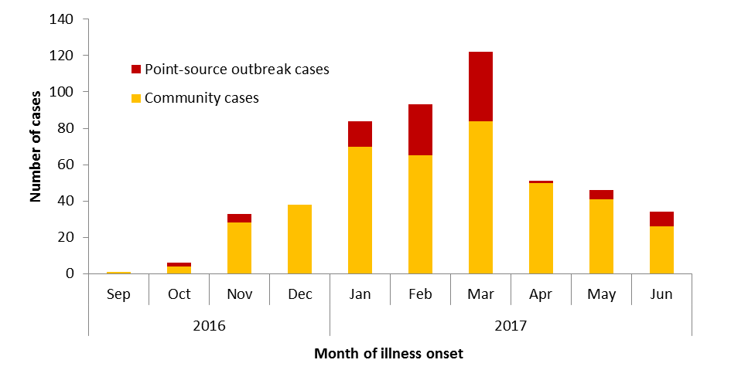

Figure 3: Notifications of *Salmonella* Typhimurium MLVA 03-17-09-12-523 in WA, 2016 to March 2017

## Rotavirus in remote regions

In the 2Q17, there were 19, 31 and 72 notifications of rotavirus in the Goldfields, Pilbara and Kimberley regions, respectively, a 3 to 17 fold increase compared to the 2QM (see Table 3 and Figure 4). Of the 122 cases, 52% were females and 48% were males with an average age of 10 years (range <1 to 73 years) and most cases (n=71; 58%) were Aboriginal people. This outbreak appears to have started in the Pilbara and Goldfields regions in March 2017 and in late April spread to the Kimberley region. At the corresponding time, large increases in undiagnosed gastroenteritis were also reported in Kimberley Aboriginal communities, primarily affecting children. The Kimberley PHU worked with remote health agencies to investigate the gastroenteritis increase and conduct health promotion in these communities to help prevent ongoing transmission. Of the 122 cases in these three regions, 26 of 27 typed specimens were identified as G2P[4] strain. This strain is not uncommon in WA with 4 to 34 cases per year between the years 2008 to 2016.

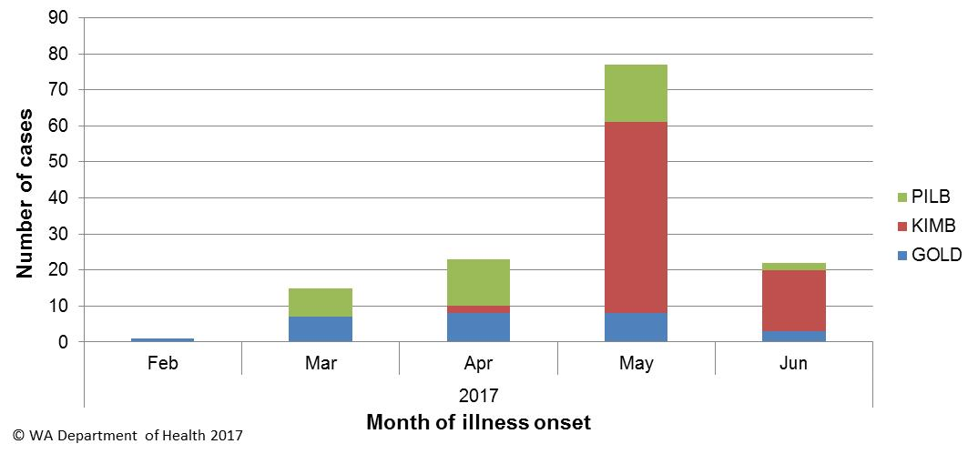

Figure 4: Rotavirus notifications in the Kimberley, Pilbara and Goldfields public health regions

## *Salmonella* Typhimurium MLVA 03-26-16-12-523

Four cases of this *Salmonella* type had visited the same holiday town during their incubation period. The diagnosed cases included four children (two males and two females) aged 1 to 11 years. Illness onsets were between 12/4/2017-17/4/2017. There were five other family members of the cases with similar (undiagnosed) illness and dates of onset. The families of the four laboratory diagnosed cases visited the town independently of each other between 7/4/2017 and 13/4/2017 and stayed at different accommodation. There are limited food venues available at the holiday town so there were some food venues in common amongst cases but no common food type was identified. However, cases did eat eggs purchased from supermarkets in the town. These eggs were from a specific WA egg producer, which also supplied eggs to a café associated with a STM outbreak (MLVA type 03-25-16-12-523) and the implicated food was breakfast eggs (reported in the 2017 first quarter).

## *Salmonella Singapore*

From February to June there were 43 cases (60% male and 40% female, median age 30 years) of *S*. Singapore notified, compared to the historic five year average of seven cases for the same time period. Most cases resided in the east (56%, n=24) and north (21%, n=9) metropolitan areas. Of these 43 cases, 19 were interviewed but no common food business was identified. Food was purchased from a range of supermarket chains and common foods eaten at home included carrots (100%), potatoes (89%), eggs (78%, but different brands), bacon (78%) and chicken pieces (67%). No hypothesis for the cause of illness could be established.

# Non-foodborne disease outbreaks and outbreaks with an unknown mode of transmission

There were 34 outbreaks of enteric disease in this quarter that appeared to be non-foodborne (Table 6). Of these, 25 outbreaks were ascribed to person-to-person transmission and 9 outbreaks had an unknown mode of transmission. A total of 482 people were affected in these 34 outbreaks, with 8 reported hospitalisations.

Table 6: Outbreaks with non-foodborne transmission, 2nd Quarter 2017, WA



1 Not all cases are diagnosed with the pathogen

2 Deaths temporally associated with gastroenteritis, but contribution to death not specified

## Person-to-person outbreaks

In the 25 non-foodborne outbreaks that were suspected to be due to person-to-person transmission, 17 (68%) outbreaks occurred in RCFs, six (24%) were in child care centres, and two (8%) in schools. The causative agent for 13 (50%) of these outbreaks was confirmed as norovirus, while astrovirus and rotavirus each caused one outbreak. The remaining 10 (38%) outbreaks were of unknown aetiology as specimens were either not collected (n=5) or were negative for common bacterial and viral pathogens (n=3), or were negative for common bacteria but no viral tests were done.

A total of 431 people were affected in these 25 outbreaks, with seven reporting hospitalisation. The number of person-to-person outbreaks in the 2Q17 was 46% higher than the second quarter 5-year mean (n=18).

## 5.2 Outbreaks with unknown mode of transmission

There were nine outbreaks in this quarter with an undetermined mode of transmission, with 51 people ill and one reported hospitalisation.

1. Five of these outbreaks were in RCFs, where the predominant or only symptom was diarrhoea. These outbreaks were unlikely to be due to norovirus due to no or limited vomiting reported. In four of the five outbreaks, the specimens collected were negative for common bacterial and viral pathogens; in one outbreak no specimens were collected.
2. Two outbreaks with an unknown mode of transmission were in childcare centres.

* In one childcare outbreak (042-2017-016), there were six children ill with diarrhoea of whom two were diagnosed with *Salmonella* Typhimurium, one with MLVA 03-13-11-10-523 and one with MLVA 03-13-11-11-523. Onset dates ranged from 7/4/2017 to the 26/4/2017. The median age of children was 2 years old. All the children had diarrhoea and vomiting but the duration of illness for the undiagnosed cases was unknown. The only food prepared and shared at the childcare centre was a fruit platter. The mode of transmission could not be determined.
* In one childcare outbreak (042-2017-014), two of 60 children were ill and diagnosed with STM MLVA 03-17-09-12-523. None of the staff reported illness. Onset of diarrhoea was 28/3/17 and 29/3/17. The only day both children attended the centre during their incubation period was 22/3/17. On this date, fruit (banana, apple, orange, watermelon), homemade chicken sausage rolls, and raisin bread were served. Staff ate the same food as the children. Illness due to this MLVA type has been associated with egg dishes but no eggs were used to prepare the food on this date. The children do not associate outside of the centre.

1. There was one outbreak in a hospital and the mode of transmission was unknown. Four staff were ill with diarrhoea only and three specimens were negative for routine pathogens and viruses.
2. There was one outbreak at a mine site where the mode of transmission was unknown. There were 10 staff ill with diarrhoea only and no specimens were tested.

# Site activities

During the second quarter of 2017, the following activities were conducted at the WA OzFoodNet site:

* Ongoing surveillance of foodborne disease in WA.
* Replied to media enquiries into the large *Salmonella* Typhimurium increase in Western Australia.
* Monitoring culture-independent nucleic acid amplification diagnostic testing in private laboratories and impact on notification rates.
* Investigation of six foodborne outbreaks.
* Investigation and monitoring of 25 person-to-person gastroenteritis outbreaks and nine outbreaks with unknown mode of transmission.
* Ongoing investigation of community-wide increases in *Salmonella* Typhimurium PFGE 0001 and PFGE 0043, and investigation of three other clusters.
* Joint meeting with FoodUnit, OzFoodNet and Assistant Director General of Public Health to discuss the increase in *Salmonella* Typhimurium notifications in Western Australia.
* Interviewing *Salmonella* Enteritidis cases regarding travel status and attempting to identify risk factors in locally acquired cases.
* Participation in combined meeting with the Department of Agriculture and Food and the Environmental Health Directorate and Communicable Disease Control Directorate to discuss zoonotic disease issues.
* Participation in combined Food Unit, OzFoodNet and PathWest meeting to help improve surveillance and investigation
* Participation in monthly national OzFoodNet teleconferences.
* In Melbourne in June, presentation of talk and poster on the large *Salmonella* Typhimurium increase in Western Australia at the CDNA/PHLN Communicable Diseases Control Conference.
* Joint authors in publication: Ng-Hublin JSY, Combs BG, Reid SC, Ryan UA, Differences in the occurrence and epidemiology of cryptosporidiosis in Aboriginal and non-Aboriginal people in Western Australia (2002−2012). [Infect Genet Evol](http://www.sciencedirect.com/science/journal/15671348) 2017;  [53](http://www.sciencedirect.com/science/journal/15671348/53/supp/C): 100-106.

# References

1. Hall G, Kirk MD, Becker N, Gregory JE, Unicomb L, Millard G, et al. Estimating foodborne gastroenteritis, Australia. Emerg Infect Dis. 2005;11(8):1257-1264.
2. OzFoodNet Working Group. A health network to enhance the surveillance of foodborne diseases in Australia. Department of Health and Ageing 2013. www.ozfoodnet.gov.au/internet/ozfoodnet/publishing.nsf/Content/Home-1 [14/03/2012].

This document can be made available in alternative formats on request for a person with a disability.

© Department of Health 2018