Foodborne disease surveillance and outbreak investigations in Western Australia, fourth quarter 2016

**Enhancing foodborne disease surveillance across Australia**



**Communicable Disease Control Directorate**



OzFoodNet, Communicable Disease Control Directorate

**Acknowledgments**

Acknowledgement is given to the following people for their assistance with the activities described in this report: Mr Damien Bradford, Ms Lyn O’Reilly, Ms Marilina Chiari and the staff from the enteric, PCR and food laboratories at PathWest Laboratory Medicine WA; Mr John Coles and other staff from the Food Unit of the Department of Health, Western Australia; Public Health Nurses from the metropolitan and regional Population Health Units; and Local Government Environmental Health Officers.

**Contributors/Editors**

Barry Combs, Nevada Pingault and Niki Foster

Communicable Disease Control Directorate

Department of Health, Western Australia

PO Box 8172

Perth Business Centre

Western Australia 6849

Email: [OzfoodnetWA@health.wa.gov.au](mailto:OzfoodnetWA@health.wa.gov.au)

Telephone: (08) 9388 4999

Facsimile: (08) 9388 4877

Web:

OzFoodNet WA Health [www.public.health.wa.gov.au/3/605/2/ozfoodnet_enteric_infections_reports.pm](http://www.public.health.wa.gov.au/3/605/2/ozfoodnet_enteric_infections_reports.pm)

OzFoodNet Department of Health

[www.ozfoodnet.gov.au/](http://www.ozfoodnet.gov.au/)

**Disclaimer**:

Every endeavour has been made to ensure that the information provided in this document was accurate at the time of writing. However, infectious disease notification data are continuously updated and subject to change.

This publication has been produced by the **Department of Health, Western Australia**.

# Executive summary

During the fourth quarter of 2016, the Western Australian (WA) OzFoodNet team conducted surveillance of enteric diseases, undertook investigations into outbreaks and was involved with ongoing enteric disease research projects.

The most common notifiable enteric infections in WA were campylobacteriosis (n=945), salmonellosis (n=502), rotavirus infection (n=63) and cryptosporidiosis (n=33) (Figure 1). Notifications of campylobacteriosis and salmonellosis were 36% and 50% higher respectively than the 5-year fourth quarter mean, while rotavirus and cryptosporidiosis notifications were lower. The large increase in salmonellosis was driven by an increase in notifications of *S*. Typhimurium PFGE 0001 (multiple MLVA types) and *S*. Typhimurium MLVA type 03-17-09-12-523.

Five foodborne outbreaks were investigated in the fourth quarter, with four due to *Salmonella* and associated with the consumption of raw egg dishes.

OzFoodNet also conducted surveillance of 49 non-foodborne outbreaks and most (n=26) were in aged care facilities. Of these, the most common mode of transmission was person-to-person (44 outbreaks), with a total of 1732 people ill. Norovirus was the most commonly reported pathogen in these outbreaks (identified in 27 outbreaks).

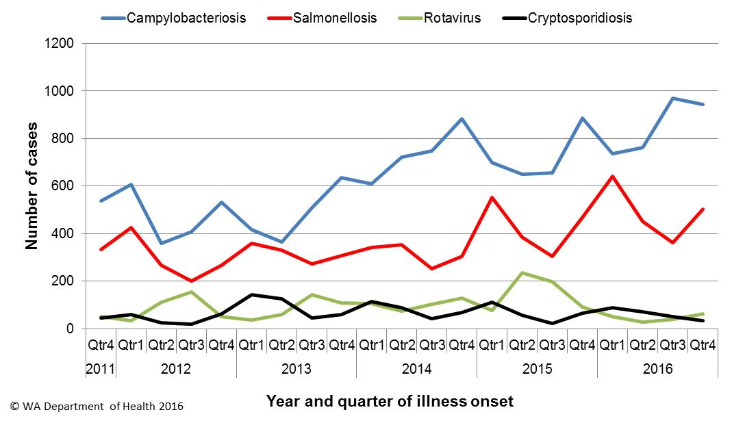

Figure 1 Notifications of the four most common enteric diseases by quarter from 2011 to 2016, WA

**Table of Contents**

Executive summary 2

1 Introduction 5

2 Incidence of notifiable enteric infections 6

2.1. Methods 6

2.2. Campylobacteriosis 6

2.3. Salmonellosis 7

2.4. Rotavirus infection 8

2.5. Cryptosporidiosis 9

2.6. Other enteric diseases and foodborne illness 10

3 Foodborne and probable foodborne disease outbreaks 12

3.1. Golf Resort restaurant, *Salmonella* Typhimurium (outbreak code 042-2016-015) 12

3.2. Restaurant outbreak, *Clostridium perfringens* (outbreak code 11/16/QUA) 12

3.3. Restaurant outbreak, *Salmonell*a Typhimurium (outbreak code 042-2016-016) 13

3.4. Restaurant outbreak, *Salmonell*a Typhimurium (outbreak code 042-2016-017) 14

3.5. Mobile food business outbreak, *Salmonell*a Typhimurium (outbreak code 042-2016-018) 14

4 Cluster investigations 15

4.1. *Salmonella* Typhimurium PFGE 0001, PT 9 15

4.2. *Salmonella* Hvittingfoss 16

4.3. *Salmonella* Typhimurium MLVA 03-17-09-12-523 16

5 Non-foodborne disease outbreaks and outbreaks with an unknown mode of transmission 17

5.1. Person-to-person outbreaks 18

5.2. Outbreaks with unknown mode of transmission 18

6 Site activities 19

7 References 20

**List of Tables**

Table 1 Number of campylobacteriosis notifications, 4th quarter 2016, WA, by region 7

Table 2 Number of salmonellosis notifications, 4th quarter 2016, WA, by region 8

Table 3 Number of rotavirus notifications, 4th quarter 2016, WA, by region 9

Table 4 Number of cryptosporidiosis notifications, 4th quarter 2016, WA, by region 10

Table 5 Summary of number of notified cases of enteric notifiable diseases in WA in the fourth quarter 2016 compared to historical means 11

Table 6 Outbreaks with non-foodborne transmission, 2nd Quarter 2016, WA 18

**List of Figures**

Figure 1 Notifications of the four most common enteric diseases by quarter from 2011 to 2016, WA 2

Figure 2 Notifications of *Salmonella* Typhimurium PFGE 0001 in WA, 2012 to September 2016 16

**Notes:**

1. All data in this report are provisional and subject to future revision.
2. To help place the data in this report in perspective, comparisons with other reporting periods are provided. As no formal statistical testing has been conducted, some caution should be taken with interpretation.

Copyright to this material is vested in the State of Western Australia unless otherwise indicated. Apart from any fair dealing for the purposes of private study, research, criticism or review, as permitted under the provisions of the Copyright Act 1968, no part may be reproduced or re-used for any purposes whatsoever without written permission of the State of Western Australia.

# Introduction

It has been estimated that there are 5.4 million cases of foodborne illness in Australia each year at a cost of $1.2 billion per year1. This is likely to be an underestimate of the total burden of gastrointestinal illness as not all enteric infections are caused by foodborne transmission. Other important modes of transmission include person-to-person, animal-to-person and waterborne transmission. Importantly, most of these infections are preventable through interventions at the level of primary production, commercial food handling, households and institution infection control.

This report describes enteric disease surveillance and investigations carried out during the fourth quarter of 2016 by OzFoodNet WA, other WA Department of Health (WA Health) agencies and local governments. Most of the data are derived from reports by doctors and laboratories to WA Health of 16 notifiable enteric diseases. In addition, outbreaks caused by non-notifiable enteric infections are also documented in this report, including norovirus, which causes a large burden of illness in residential (mostly aged) care facilities (RCF) and the general community.

OzFoodNet WA is part of the Communicable Disease Control Directorate (CDCD) within WA Health, and is also part of the National OzFoodNet network funded by the Commonwealth Department of Health2. The mission of OzFoodNet is to enhance surveillance of foodborne illness, including investigating and determining the cause of outbreaks. OzFoodNet also conducts applied research into associated risk factors and develops policies and guidelines related to enteric disease surveillance, investigation and control. The OzFoodNet site based in Perth is responsible for enteric disease surveillance and investigation in WA.

OzFoodNet WA regularly liaises with staff from: Public Health Units (PHUs); the Food Unit in the Environmental Health Directorate of WA Health; and the Food Hygiene, Diagnostic and Molecular Epidemiology laboratories at PathWest Laboratory Medicine WA.

PHUs are responsible for a range of public health activities, including communicable disease control, within their respective administrative regions. The PHUs monitor RCF gastroenteritis outbreaks and provide infection control advice. The PHUs also conduct follow-up of sporadic cases of important enteric diseases including typhoid, paratyphoid and hepatitis A.

The Food Unit liaises with Local Government (LG) Environmental Health Officers (EHO) during the investigation of food businesses. The Food Hygiene, Diagnostic and Molecular Epidemiology laboratories at PathWest Laboratory Medicine WA provide public health laboratory services for the surveillance and investigation of enteric disease.

# Incidence of notifiable enteric infections

## Methods

Enteric disease notifications were extracted from the Western Australian Notifiable Infectious Diseases Database (WANIDD) by optimal date of onset (ODOO) for the time period 1st October 2011 to 31st December 2016. The ODOO is a composite of the ‘true’ date of onset provided by the notifying doctor or obtained during case follow-up, the date of specimen collection for laboratory notified cases, and when neither of these dates is available, the date of notification by the doctor or laboratory, or the date of receipt of notification, whichever is earliest. Rates were calculated using estimated resident population data for WA from Rates Calculator version 9.5.5 (WA Health, Government of Western Australia), which is based on 2011 census data. Rates calculated for this report have not been adjusted for age.

## Campylobacteriosis

Campylobacteriosis was the most commonly notified enteric disease in WA during the fourth quarter of 2016 (4Q16), with 945 notifications and a rate of 142 cases per 100 000 population per year (Table 1). There was a 36% increase in campylobacteriosisnotifications in the 4Q16 compared with the 5-year fourth quarter mean (4QM) of 695 notifications. The increase appeared to be due to sporadic disease, as there were no identified *Campylobacter* outbreaks during the 4Q16. At least some of the increase is likely to be due to the introduction by one large private pathology laboratory of polymerase chain reaction (PCR) testing of faecal specimens, which has greater sensitivity than culture techniques.

The place of acquisition of infection was reported for 62% (n=586) of cases, of which 80% (n=471) were locally acquired and 19% (n=111) were acquired overseas.

Table 1 Number of campylobacteriosis notifications, 4th quarter 2016, WA, by region



**\***Percentage change in the number of notifications in the current quarter compared to the historical 5-year mean for the same quarter. Positive values indicate an increase when compared to the historical 5-year mean of the same quarter. Negative values indicate a decrease when compared to the historical 5-year mean of the same quarter. Percentage change should be interpreted with caution when the number of cases is small.

## Salmonellosis

Salmonellosis was the second most commonly notified enteric disease in WA in the 4Q16, with 502 notifications and a rate of 76 cases per 100 000 population per year (Table 2). The number of salmonellosisnotifications in the 4Q16 was 50% higher than the 4QM (n=336), with the increase occurring primarily in the Perth metropolitan.

Place of acquisition of infection was reported for 77% (n=386) of cases, of which 71% (n=274) were locally acquired, 27% (n=105) were acquired overseas and 1% (n=3) were acquired interstate.

The most commonly reported *Salmonella* serotype was *S*. Typhimurium (STM) (n=259, 52%), and of those cases with information on place of acquisition (n=202, 78%), 97% of cases (n=196) were locally acquired. Pulsed-field gel electrophoresis (PFGE) was previously used for subtyping of STM in WA, but as of the beginning of 2016, multi locus variable number tandem repeat analysis (MLVA) has replaced PFGE. The most common MLVA types for 4Q16 were 03-17-09-12-523 (n=77, 30%, PFGE type 0043), 03-25-18-11-523 (n=28, 11%, PFGE type 0001), 03-25-16-11-523 (n=24, 9%, PFGE type 0001) and 03-25-16-12-523 (n=9, 3%, PFGE type 0001). The MLVA type 03-17-09-12-523 has recently emerged (Section 4) with two point source outbreaks identified in this quarter (Section 3). There has also been an ongoing community wide outbreak of PFGE 0001 in WA over the past two years (Section 4), including many identified point source outbreaks of this STM PFGE type (Section 3).

Table 2 Number of salmonellosis notifications, 4th quarter 2016, WA, by region



**\***Percentage change in the number of notifications in the current quarter compared to the historical 5-year mean for the same quarter. Positive values indicate an increase when compared to the historical 5-year mean of the same quarter. Negative values indicate a decrease when compared to the historical 5-year mean of the same quarter. Percentage change should be interpreted with caution when the number of cases is small.

NA: not applicable as there is a 0 value in the calculation for the 4th quarter % change

*S*. Enteritidis was the second most common *Salmonella* serotype (n=52, 10%), with most (n=48, 94%) cases acquired overseas, primarily after travel to Indonesia (n=35, 73%), and almost exclusively to Bali.

*Salmonella* Paratyphi B bv javawas the next most common serotype (n=21), with 88% of cases acquired overseas and 12% acquired in WA. There were also 16 notifications of *Salmonella* Virchow and most (77%) of these notifications were acquired in WA. In addition, there were 18 notifications of *Salmonella* that had no serotype. Most (61%) of these notifications were from one laboratory that first uses PCR screening for enteric pathogens. Specimens that are subsequently culture negative remain as a “PCR only” notification.

## Rotavirus infection

In the 4Q16 there were 63 notifications of rotavirus infection (10 cases per 100 000 population per year), a 34% decrease compared with the mean of the previous 4 years (Table 3). Notifications were predominantly seen in the Perth metropolitan area in the 4Q16. Of the cases with known Aboriginality status, most (93%) cases were non-Aboriginal. The median age was 1 year old (range <1 years to 93 years).

Table 3 Number of rotavirus notifications, 4th quarter 2016, WA, by region

|  |  |  |  |
| --- | --- | --- | --- |
|  | **Number of notifications** | | |
| **Region** | **2016 4th Quarter** | **5 Year Mean for 4th Quarter** | **4th Quarter % change\*** |
| East Metro | 32 | 21 | 54 |
| North Metro | 15 | 26 | -43 |
| South Metro | 8 | 21 | -61 |
| Goldfields | 5 | 6 | -17 |
| Great Southern | 1 | 1 | -20 |
| Midwest | 1 | 2 | -50 |
| Pilbara | 1 | 4 | -75 |
| Wheatbelt | 0 | 2 | NA |
| Kimberley | 0 | 3 | NA |
| WA address not specified | 0 | 1 | NA |
| South West | 0 | 9 | NA |
| Total | 63 | 95 | -34 |
| © WA Department of Health 2016 | |  |  |

*Percentage change in the number of notifications in the current quarter compared to the historical 4-year mean for the same quarter. Positive values indicate an increase when compared to the historical 4-year mean of the same quarter. Negative values indicate a decrease when compared to the historical 4-year mean of the same quarter. Percentage change should be interpreted with caution when the number of cases is small.

**Rotavirus: comparison to four years (2012-2015) of data only because laboratory testing and notification practices (increased use of more specific PCR over antigen testing) have changed since the beginning of 2012.

NA: not applicable as there is a 0 value in the calculation for the 4th quarter % change

## Cryptosporidiosis

In the 4Q16 there were 33 cryptosporidiosis notifications (5 cases per 100 000 population per year), a 45% decrease compared to the 4QM (Table 4).

The place of acquisition of infection was reported for 55% (n=18) of cases of which 72% (n=13) were locally acquired.

Table 4 Number of cryptosporidiosis notifications, 4th quarter 2016, WA, by region



**\***Percentage change in the number of notifications in the current quarter compared to the historical 5-year mean for the same quarter. Positive values indicate an increase when compared to the historical 5-year mean of the same quarter. Negative values indicate a decrease when compared to the historical 5-year mean of the same quarter. Percentage change should be interpreted with caution when the number of cases is small.

NA: not applicable as there is a 0 value in the calculation for the 4th quarter % change

## Other enteric diseases and foodborne illness

During the 4Q16, other enteric disease notifications included:

* **Shigellosis**: There were 21 shigellosis notifications in 4Q16 that were culture positive, which was 12% higher than the 4QM (n=18.8) (Table 5). *Shigella* *sonnei* was the most commonly notified species (20/21), with 10 cases each of *S. sonnei* biotype A and biotype B. There was also one case of *S. flexneri*. Of the notified cases, eight (38%) were Aboriginal people, 13 (62%) were non-Aboriginal people. The place of acquisition of infection was reported for 71% (n=15), and 67% (n=10) were acquired in Western Australia.
* **Shiga toxin *E. coli* (STEC):** Thirteen cases were notified in 4Q16 compared to the 4QM of 1 case. Prior to 2016, STEC was only diagnosed in one laboratory and this was by culture. The increase in cases in 4Q16 was likely due to the introduction in 2016 of PCR testing for STEC on stool samples with bloody diarrhoea at that laboratory and PCR testing of any stool sample on request in another laboratory. The 13 cases include four males and nine females, ranging in age from 1-87 years (median 28 years). Ten of 13 cases had an acute illness with a specific onset date and eight of these cases had bloody diarrhoea. Two cases were siblings, with one of these cases also developing HUS. The source of STEC infection for the sibling is unclear. However, they did eat home-made sausage but this was negative for STEC by PCR. Three cases did not have an acute illness but had diarrhoea intermittently over a long period of time.
* ***Vibrio parahaemolyticus*:** There were five *V. parahaemolyticus* notifications in 4Q16. There were two males and three female with ages ranging from 48 to 59 year old. One case acquired their infection in Western Australian and four acquired infections overseas including Indonesia (n=3) and Singapore (n=1)
* **Hepatitis A infection:** Four hepatitis A cases were notified in 4Q16, with one case acquiring their infection overseas in Vietnam and one in Afghanistan. One case’s infection was very likely due to secondary transmission as they did not travel and their parent was the case who visited Vietnam. The last case also did not travel overseas and spent their incubation period in Victoria and Western Australia.
* **Typhoid fever:** Three cases were notified in this quarter with two cases travelling to India and one case had travelled to Bangladesh.
* **Yersiniosis:** There was one case of culture-positive yersiniosis notified in 4Q16, in an 11 year old male.

There were no notifications forbotulism, cholera, hepatitis E, listeriosis and paratyphoid fever.

Table 5 Summary of number of notified cases of enteric notifiable diseases in WA in the fourth quarter 2016 compared to historical means



**\*** Rotavirus first quarter change compared to the 4-year mean 2012-2015 as previously described in Section 2.4.

NA:not applicable as there is a 0 value in the calculation for the 4th quarter % change

# Foodborne and probable foodborne disease outbreaks

There were five foodborne outbreaks investigated in this quarter.

## Golf Resort restaurant, *Salmonella* Typhimurium (outbreak code 042-2016-015)

In September 2016, there were nine cases (confirmed) of STM MLVA type 03-24-13-14-523 and two cases (suspected) of gastroenteritis who was either patrons or staff of a Golf Resort. The cases were seriously ill with 64% experiencing bloody diarrhoea and one was hospitalised.

The six patrons had independently eaten at the resort from the 4-9/9/2016. The median incubation period for patrons eating at the resort restaurant to becoming ill was 52 hours.

The food eaten by the cases included steak sandwiches, other sandwiches and fish & chips and all these meals included either raw egg aioli or tartare sauce. All the ill staff had eaten left over food prepared by the resort and two could recall eating sandwiches also eaten by one of the cases. Staff completed a questionnaire on illness and food eaten during the same time period as the patrons. An analysis of the data showed a significant association between eating sandwiches and salt & pepper squid and becoming ill. Both these meals were likely to have contained raw egg sauces.

The environmental health officer (EHO) reported that a base raw egg sauce was used to make aioli, tartare and Caesar sauces. The base sauces were made twice weekly, containing raw egg, vinegar, oil and prepared in 10 litres batches. Raw egg sauce samples from the resort were negative for *Salmonella* but these were not the same batch as what was eaten by the patrons or ill staff. The evidence suggests that illness was due to foodborne transmission from eating raw egg sauces.

## Restaurant outbreak, *Clostridium perfringens* (outbreak code 11/16/QUA)

On 28th October 2016, 24 people in one group had food at a roadhouse restaurant and at least six people later became ill. The people had two meal options either fish & chips or an Indian meal which included curries and a rice dish (pea pulao). The ill people had a short incubation period of 11 hours and all had diarrhoea, with no vomiting reported. One stool specimen was tested for *C. perfringens* and this was positive for culture and toxin. The statistical analysis showed that eating curry and the rice dish was statistically associated with illness. The people who ate the Indian meal were likely to have had curry with the rice dish together so it was difficult to determine which specific food caused the illness.

The environmental health investigation found that the Indian meal was prepared in another country town by a caterer and transported for 1.5 hours to the roadhouse either in an esky or with alfoil covering the dish. This lack of temperature control would have provided ideal conditions for the growth of *C. perfringens*. The evidence suggests that this outbreak was due to foodborne transmission.

## Restaurant outbreak, *Salmonell*a Typhimurium (outbreak code 042-2016-016)

There were two cases (confirmed) of STM MLVA type 03-17-09-12-523 and one case (suspected) of gastroenteritis who had eaten dinner together at a Chinese Restaurant on 22nd October. The median incubation period was 25 hours. Two confirmed cases were hospitalised. One confirmed case and the suspected case were siblings but neither had been in contact with the second confirmed case for at least two weeks prior to the dinner. The food consumed by the cases included satay chicken, sweet and sour pork, sizzling beef, fried rice with prawns and deep fried icecream. All foods were eaten by all cases except the fried rice with prawns which was only eaten by the siblings. An environmental investigation was conducted and the same MLVA type of STM was isolated from deep fried icecream ingredients including the ice cream with crumb mix and the bread crumb batter. The bread crumb batter was prepared in advance and frozen between uses. Eggs used in the batter were sourced from a producer located in another state. Tests of whole shell eggs were negative for *Salmonella*. The restaurant has taken the items of the menu until the local government authority is satisfied that their processes and procedures comply with the Food Standards Code and they have been issued infringement notices. The mode of transmission was foodborne.

## Restaurant outbreak, *Salmonell*a Typhimurium (outbreak code 042-2016-017)

In December 2016, there were five cases (confirmed) of STM MLVA type 03-17-09-12-523 and one case (suspected) of gastroenteritis who had eaten dinner at a Chinese restaurant on 24th November. This included a group of seven people with five ill, and a group of two people with one ill. The median incubation period was 36 hours. No one was hospitalised. Both ill and well people from the group of seven were interviewed with a structured questionnaire. The last time this group were together was approximately 2 weeks prior. Foods consumed included two special fried rice (one without peas), honey king prawns, chicken cashews, sweet and sour pork, combination omelette, Singapore mei fun, and lamb satay. The combination omelette was the only food or drink significantly associated with illness (P value=0.048; OR undefined). Both well people did not have the omelette and all ill people ate the omelette. STM 03-17-09-12-523 was also isolated from the omelette mix when samples were collected by the EHO approximately two weeks after the dinner. The eggs used by the restaurant were eggs from a Western Australian egg producer. Omelette mix was prepared in batches of 6 dozen eggs and stored for up to 2 days. Corrective actions were recommended to the business by the EHO.

## Mobile food business outbreak, *Salmonell*a Typhimurium (outbreak code 042-2016-018)

At least 13 people diagnosed with STM MLVA type 03-25-16-11-523 (PFGE 0001) became ill after eating food from a mobile food business that sells foods at markets and festivals. Cases were interviewed using a structured questionnaire containing questions about their illness and food they ate. Cases had eaten food from the food business at three different locations. Most people became ill between 27/11/2017 to 4/12/2017 with one case becoming ill on the 29/12/2017. Symptoms included diarrhoea (n=13), bloody diarrhoea (n=5), vomiting (n=7) and fever (n=12) and two cases were admitted to hospital. The median incubation period was 2.5 days. All the cases had eaten cous cous meals with a whole egg placed on top. The eggs were poached in a tomato sauce prior to serving. The eggs used were free range eggs from a Western Australian egg producer. Eggs sampled were negative for *Salmonella*. A previous outbreak due to this MLVA type was also associated with a raw egg dish and the eggs were from the same egg producer. Food safety officers investigated the food business and found good food handling practices and staff education. At that time there was no environmental investigation of the egg producer. The evidence suggests that illness was due to foodborne transmission.

# Cluster investigations

There was one ongoing and two new cluster investigations during the fourth quarter of 2016.

## *Salmonella* Typhimurium PFGE 0001, PT 9

Since the beginning of 2014, there has been an ongoing investigation of a community-wide outbreak in WA of notifications of MLVA types analogous to STM PFGE 0001 (Figure 2). This has been the largest *Salmonella* outbreak ever investigated in WA. From January 2014 to December 2016 there was 877 cases notified, with an additional 95 cases with onset dates in the 4th quarter of 2016. Of the 95 cases, 15 were part of two point source outbreaks. One outbreak is detailed in Section 3 and the other outbreak will be reported in the 2017 first quarter report. The remaining 80 cases, comprising 46% males and 54% females, ranged in age from <1 to 90 years (average 33 years), and most (78%) resided in the Perth metropolitan area.

From January 2015 there have been 15 point source outbreaks due to STM PFGE 0001 and of these, egg dishes have been the implicated food in 14 outbreaks. Raw eggs were part of the implicated dishes for ten outbreaks, and in four outbreaks eggs were served as part of the meals. In 11 of these outbreaks, the egg producer was known. In seven outbreaks, eggs were from producer C, and in one outbreak each, eggs were from producers A, B, D and E.

Independent of the outbreak investigations, samples have been collected from eggs, egg laying chickens and retail chicken meat. STM PFGE 0001 has been isolated on five occasions from eggs or egg laying chickens from producer C, twice from egg producer B and once from egg producer A. Retail chicken meat sampled in September 2014 was also positive for PFGE 0001.

From February 2015 to March 2016, non-point source outbreak cases (community cases) were investigated as part of a case-control study of STM PFGE 0001 illness. Final analysis of the case control data showed that eating raw eggs was statistically associated with illness.

This evidence suggests eating raw/runny eggs is the cause of STM PFGE 0001 point source outbreaks in WA and it is very likely the cause of many of the community cases.

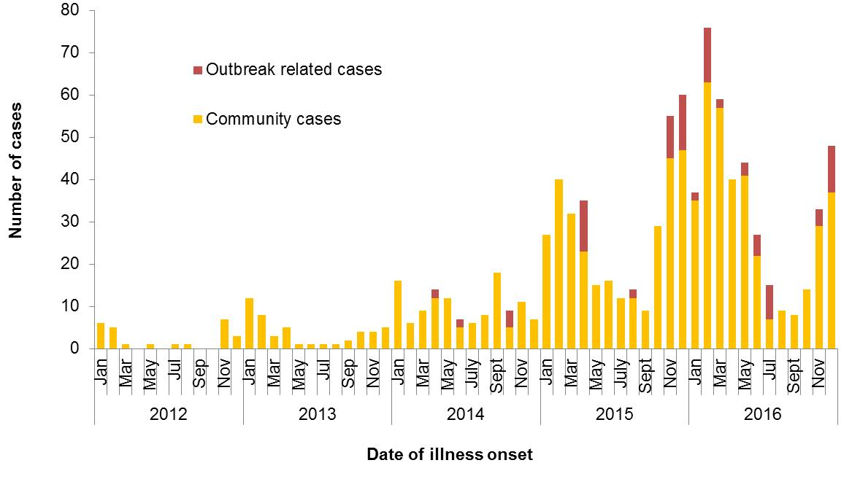

Figure 2 Notifications of *Salmonella* Typhimurium PFGE 0001 in WA, 2012 to September 2016

## *Salmonella* Hvittingfoss

In the fourth quarter 2016, there were 13 cases of *S*. Hvittingfoss compared to a 5-year average of 1 case. Two cases were hospitalised. The median age was 55 years (range 22-87) with 5 males and 8 females, 11 cases lived in metropolitan Perth and two lived in rural areas. Of the 13 cases, isolates of 10 cases were typed by PFGE as type B2 (n=6), B5 (n=3) and C1 (n=1). These PFGE types were different to the strain associated with the MJOI outbreak in July 2016. No hypothesis for the cause of illness could be established.

## *Salmonella* Typhimurium MLVA 03-17-09-12-523

Up until September 2016, STM MLVA 03-17-09-12-523 had not been notified in WA since MLVA began in WA in January 2015. Following a single case in September, in the 4th quarter of 2016 there were 77 cases (Figure 3). Of the 77 cases, seven were part of two point source outbreaks. Both outbreaks are detailed in Section 3. The remaining 70 cases, comprising 43% males and 57% females, ranged in age from 1 to 81 years (average 35 years), and most (81%) resided in the Perth metropolitan area. Hospitalisation data was confirmed for 56 community cased; 36% were hospitalised.

Eggs were implicated in both point source outbreaks of STM 03-17-09-12-523 in the 4th quarter of 2016. The egg producer was different in each outbreak. Of the 70 cases not part of these point source outbreaks, 56 were interviewed regarding egg consumption; 77% had consumed eggs in their incubation period, 11% had not, and 13% were unsure. Several different egg brands were reported by cases including the brand of eggs implicated in one of the point source outbreaks. In the 4Q16, STM MLVA 03-17-09-12-523 was isolated from an environmental sample from an egg farm.

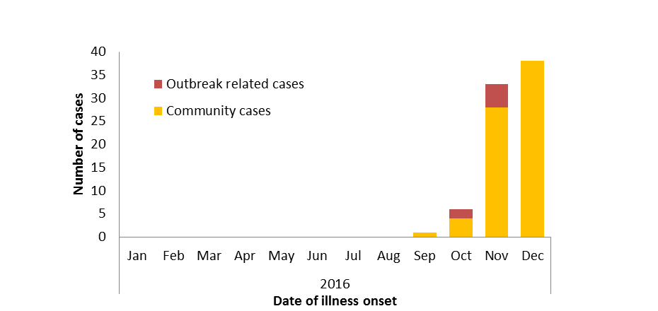

Figure 3 Notifications of *Salmonella* Typhimurium MLVA 03-17-09-12-523 in WA, 2016

# Non-foodborne disease outbreaks and outbreaks with an unknown mode of transmission

There were 49 outbreaks of enteric disease in this quarter that appeared to be non-foodborne (Table 6). Of these, 44 outbreaks were ascribed to person-to-person transmission and five outbreaks had an unknown mode of transmission.

Table 6 Outbreaks with non-foodborne transmission, 4th Quarter 2016, WA



1 Deaths temporally associated with gastroenteritis, but contribution to death not specified

## Person-to-person outbreaks

In the 44 non-foodborne outbreaks that were suspected to be due to person-to-person transmission, 26 (59%) outbreaks occurred in RCFs, eight (18%) were in child care centres, four (9%) were in hospitals, three (7%) on separate cruise ship voyages, two (5%) at schools and one (2%) at a sporting event. The causative agent for 27 (61%) outbreaks was confirmed as norovirus and two (5%) were confirmed as rotavirus. The remaining 15 (34%) outbreaks were of unknown aetiology as specimens were either not collected (n=13), were negative for common bacterial pathogens and viral tests not requested (n=1) or were negative for common viral pathogens and bacterial tests not requested (n=1).

A total of 1732 people were affected in these 44 outbreaks, with 23 reported hospitalisations. The number of person-to-person outbreaks in the 4Q16 was 47% lower than the fourth quarter 5-year mean (n=23).

## Outbreaks with unknown mode of transmission

There were five outbreaks in this quarter with an undetermined mode of transmission, with 34 people ill and two reported hospitalisations. Three of these outbreaks were in RCFs including one where four people were ill with diarrhoea only but no specimens were tested. Another outbreak in a RCF had six ill with diarrhoea only. One specimen was collected and this was negative for routine viral and bacterial pathogens. These outbreaks were unlikely to be due to norovirus as no vomiting was reported. In the third RCF outbreak, three people were ill with two diagnosed with *Campylobacter*. The ill onset dates were 4/12, 6/12 and 8/12 so it is unclear if the illness was due to foodborne or person to person transmission. In one outbreak at a work function in a restaurant, nine people became ill with diarrhoea and vomiting and no stool specimens were tested. This outbreak was only investigated by a local government environment officer and there was insufficient information to determine the mode of transmission.

The fifth outbreak was also set at a restaurant. Twelve people became ill with stomach cramps, diarrhoea and/or vomiting 5-34 hours after attending a birthday dinner in a group of approximately 34 people. An analytical study could not be performed due to the small number of questionnaires returned. No stool specimens were tested. Inspection by a local government environment officer did not identify any deficiencies and there were no cases of staff illness reported prior to, or at the time of the outbreak. There had been no other complaints of illness from other groups served the same foods. There was insufficient information to determine the mode of transmission.

# Site activities

During the fourth quarter of 2016, the following activities were conducted at the WA OzFoodNet site:

* Ongoing surveillance of foodborne disease in WA.
* Monitoring culture-independent nucleic acid amplification diagnostic testing in private laboratories and impact on notification rates.
* Investigation of five foodborne outbreaks.
* Investigation and monitoring of 44 person-to-person gastroenteritis outbreaks and five outbreaks with unknown mode of transmission.
* Ongoing investigation of a community-wide increase in *Salmonella* Typhimurium PFGE 0001 and investigation of two other clusters.
* Interviewed locally acquired *Campylobacter* cases as part of a pilot study on *Campylobacter* molecular typing which is a collaborative project between OzFoodNet, the Food Unit, PathWest and Murdoch University.
* Presented preliminary findings of the *Campylobacter* typing study at the November meeting of the ISFR coordinated food survey planning workshop.
* Presented at Public Health Unit nurses update on Western Australian enteric disease surveillance and investigation.
* Responded to national OzFoodNet enteric disease surveillance requests.
* Presented findings of *Salmonella* Typhimurium PFGE type 0001 outbreak investigations at the biannual meeting in November with Department of Agriculture and Food and the Department of Health.
* In November, OzFoodNet and the Food Unit conducted training of environmental health officers in Bunbury on foodborne outbreak investigation.
* Interviewing *Salmonella* Enteritidis cases regarding travel status and attempting to identify risk factors in locally acquired cases.
* Membership of OzFoodNet working groups on:
  + Outbreak register
  + Foodborne disease tool kit
  + Culture-independent diagnostic testing
* In November, attended 50th National OzFoodNet face-to-face meeting in Canberra and gave a presentation on STEC surveillance in Australia.
* Participation in combined Food Unit, OzFoodNet and PathWest meeting to help improve surveillance and investigation
* Participation in monthly national OzFoodNet teleconferences.

# References

1. Hall G, Kirk MD, Becker N, Gregory JE, Unicomb L, Millard G, et al. Estimating foodborne gastroenteritis, Australia. Emerg Infect Dis 2005;11(8):1257-1264.
2. OzFoodNet Working Group. A health network to enhance the surveillance of foodborne diseases in Australia. Department of Health and Ageing 2013. www.ozfoodnet.gov.au/internet/ozfoodnet/publishing.nsf/Content/Home-1 [14/03/2012].

This document can be made available in alternative formats on request for a person with a disability.

© Department of Health 2016